SOCIAL PROGRAM
CROSS-BORDER MEETING, THE 6TH EDITION
Chişinau, Republic of Moldova June 21-23, 2012
“THE ROLE AND RESPONSIBILITIES OF THE PROFESSIONAL ASSOCIATIONS IN REGULATING THE ACCOUNTING PROFESSION”

Day 1 (21/06/2012)

Time | Activity
18:30 – 19:00 | Transfer from Leogrand Hotel to Vatra Neamului Restaurant
19:00 – 22:00 | Welcome dinner at Vatra Neamului Restaurant. Folk music program
22:00 – 22:15 | Transfer/walk from Vatra Neamului Restaurant to Leogrand Hotel

Day 2 (22/06/2012)

Time | 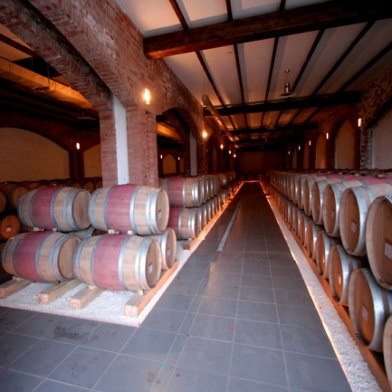Activity
17:00 – 18:00 | Transfer from Leogrand Hotel to Chateau Vartely Winery
18:00 – 22:30 | Excursion, wine tasting and dinner at Chateau Vartely Winery  Chateau Vartely is a modern resort, which comprises four hotel-type houses, 2 restaurants, 3 tasting rooms, and a huge inner yard. In the cellars and then in tasting rooms you will be acquainted with the particularities of the “Chateau Vartely” wines. Also you will get to know the best labels of local wine and learn about the right way there are made, kept and served and will have this chance to taste one of it.
22:30 – 23:00 | Transfer from Chateau Vartely Winery to Leogrand Hotel

Day 3 (23/06/2012)
Time | Activity
08:30 – 09:30 | Transfer from Leogrand Hotel to Orheiul Vechi Complex
09:30 – 11:00 | Excursion at Orheiul Vechi – a 40 thousand year-old amphitheater  The remnants of the first human settlements, which are some hundreds of thousands years old, were found in the stone caverns from here. On the rocky hill, you’ll find the ruins of a strong Geto-Dacian (Moldavian ancestors) fortification and a cave monastery.  The originality of Orheiul Vechi's landscape is due to the defile of the Raut river, dug under the form of a canyon in the limestone layers of the former Sarmatian sea, about 14 million years ago.
11:00 – 12:00 | Brunch at the Casa Verde Agro pension in Trebujeni village
12:00 – 13:00 | Transfer from Orheiul Vechi Complex to Leogrand Hotel
